## Design screen for George Carr - Portfolio Website

### Skeleton Mobile. Breakpoint below 768 px

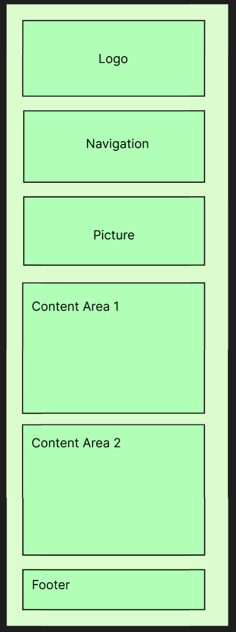

### Skeleton Desktop

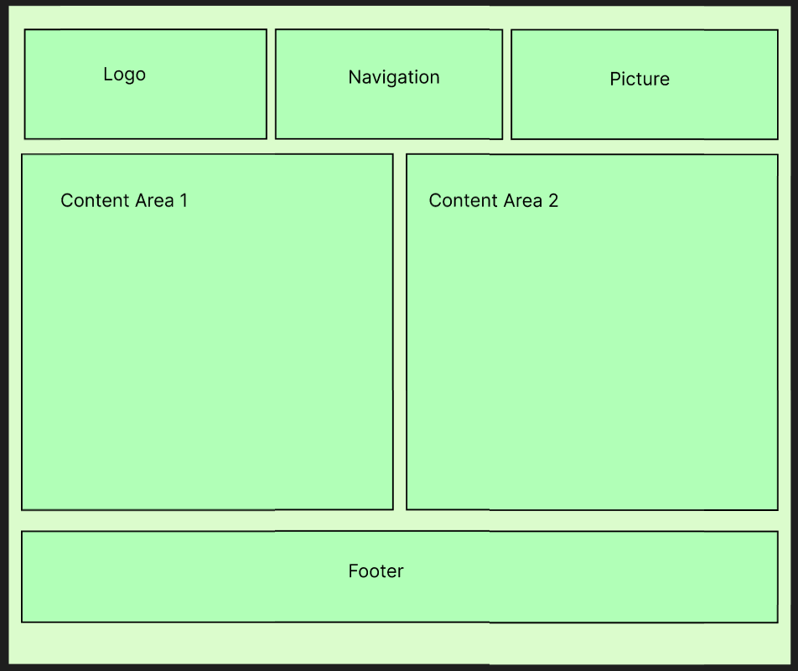

### Surface Desktop - Resume Page



### Surface Desktop - Home Page



Surface Desktop - Contact Page



Surface Mobile - Resume Page used as an example of the differences.

